* Step 1: Setup Database
* Setup MS SQL 2008.
* Start "SQL Server Management Studio".
* Connect to server with username and password
* Choose File->Open->File :
  + Explore to the Claim.sql in folder Database of Project.
  + Click open
* On query windows select all (Ctrl+A) and execute (F5) to init database
* If the database exists, please drop the database and execute init file again.
* Step 2: Deploy project on Glassfish server.
* Setup Glassfish server by setup file (with default value , version should be glassfish-4.0).
* Go to %glassfish-root%/glassfish/bin: run startserv.bat as administrator.
* Waiting until server started.
* Open browser.
* On address bar enter : localhost:4848 to open Glassfish server Administration Console

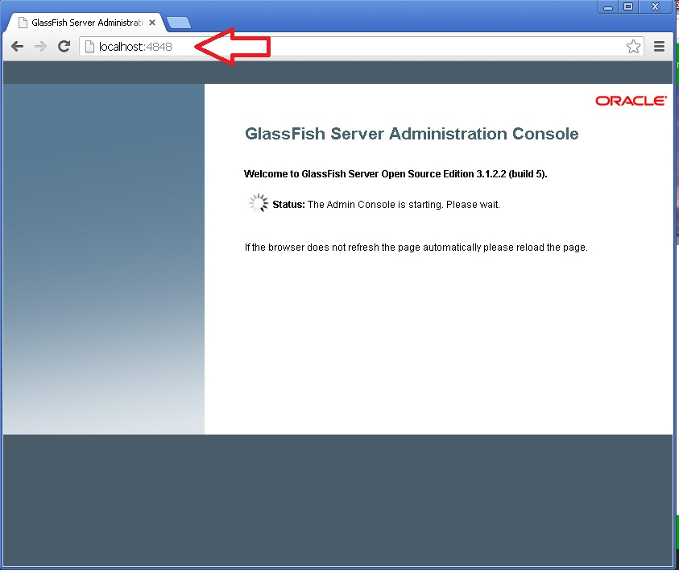

* Waiting until page loaded
* On Common Tasks list go Resources>JDBC>JDBC Connection Pools : click New

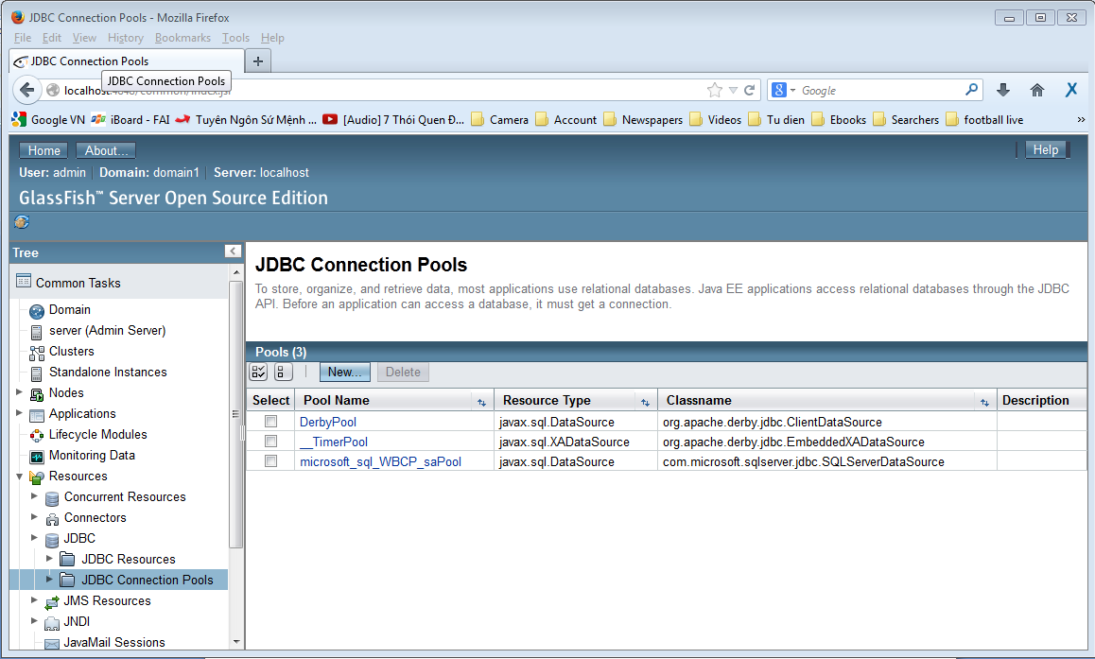

* Config like the picture below then press next :

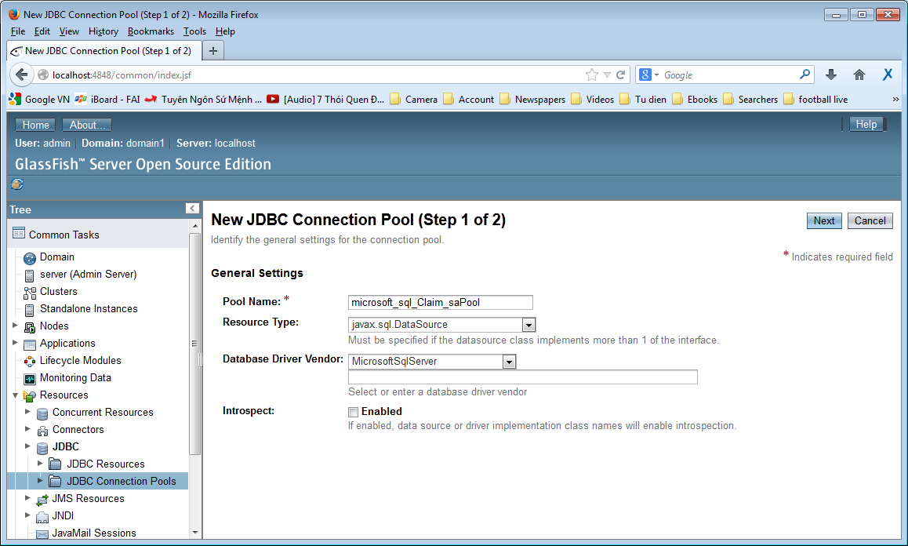

* In the next page scroll down to the Additional Properties Table and enter username and password of database and some information like this :

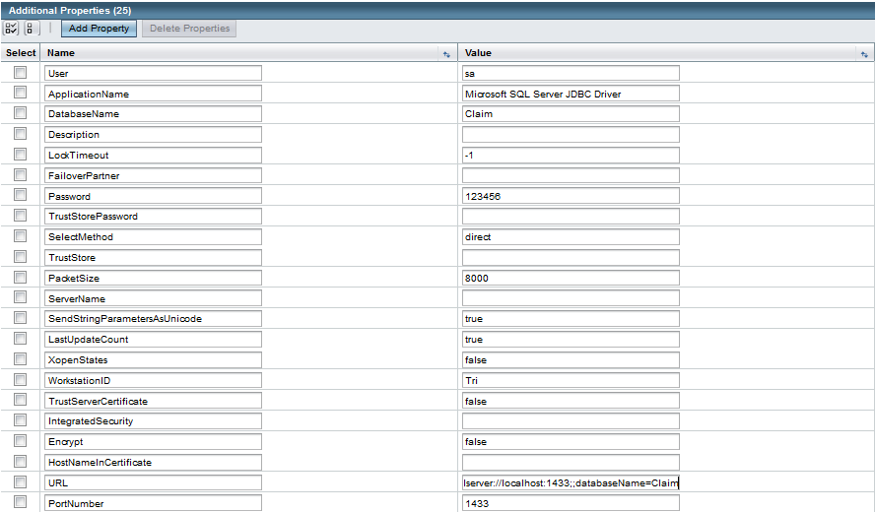

* default value :
* username : sa
* password : 123456
* URL : jdbc:sqlserver://localhost:1433;databaseName=Claim
* On Common Tasks list go Resources>JDBC>JDBC Resoucres click New then Enter these value :

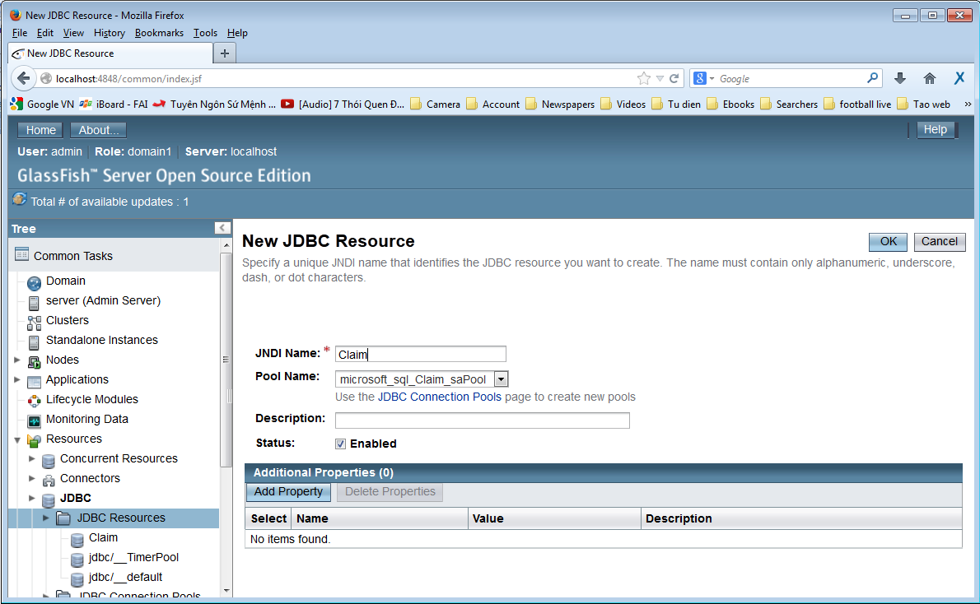

* Press OK
* Click on "Deploy an Application" button on Common Tasks Page.

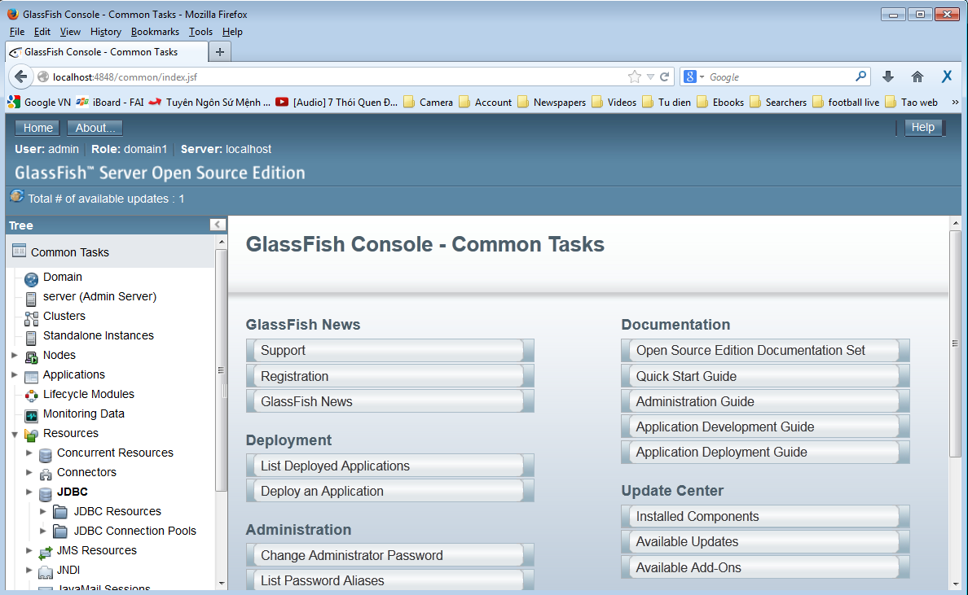

* Then choose Claim.ear file in folder Sourcecode/dist/ of Project and upload to server

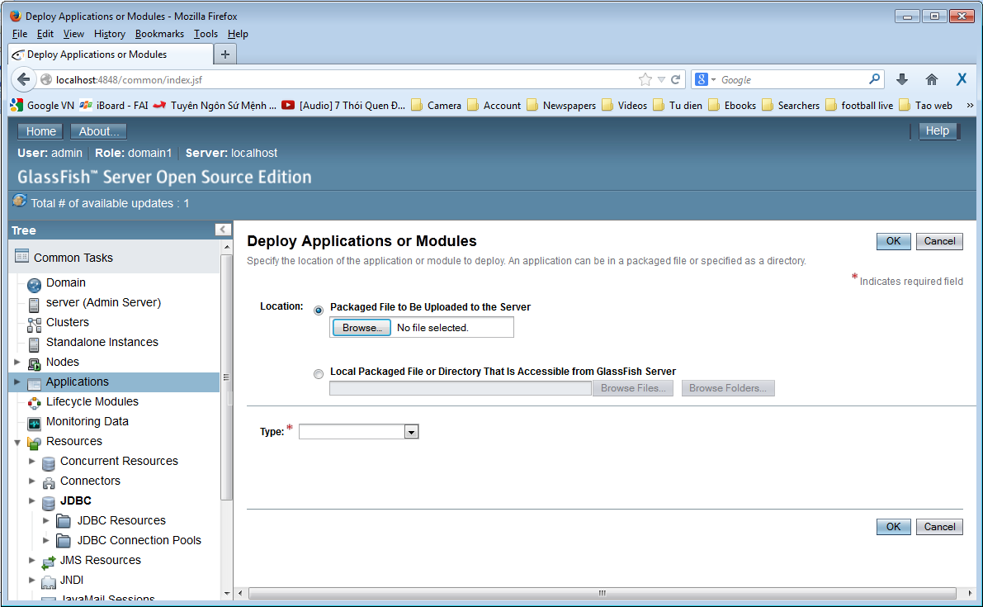

* Then press "OK" button

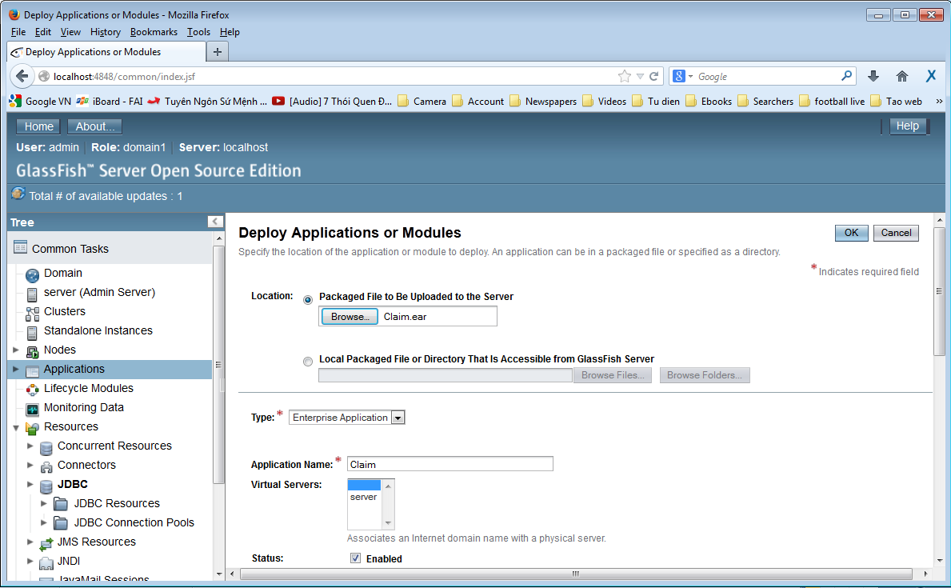

* If the application has same name with another one, please rename at “Application Name” text field.
* If the deployment does successfully , you will see your project name in the list of application on server .

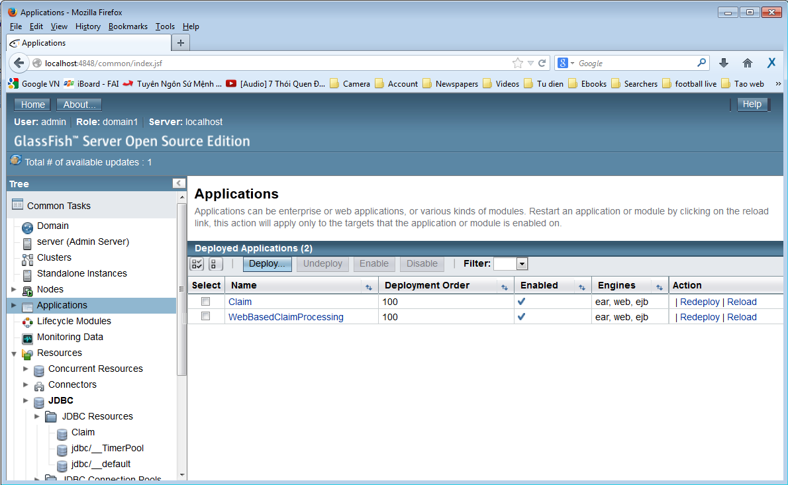

* Click on the Name of the Project will show the page below :

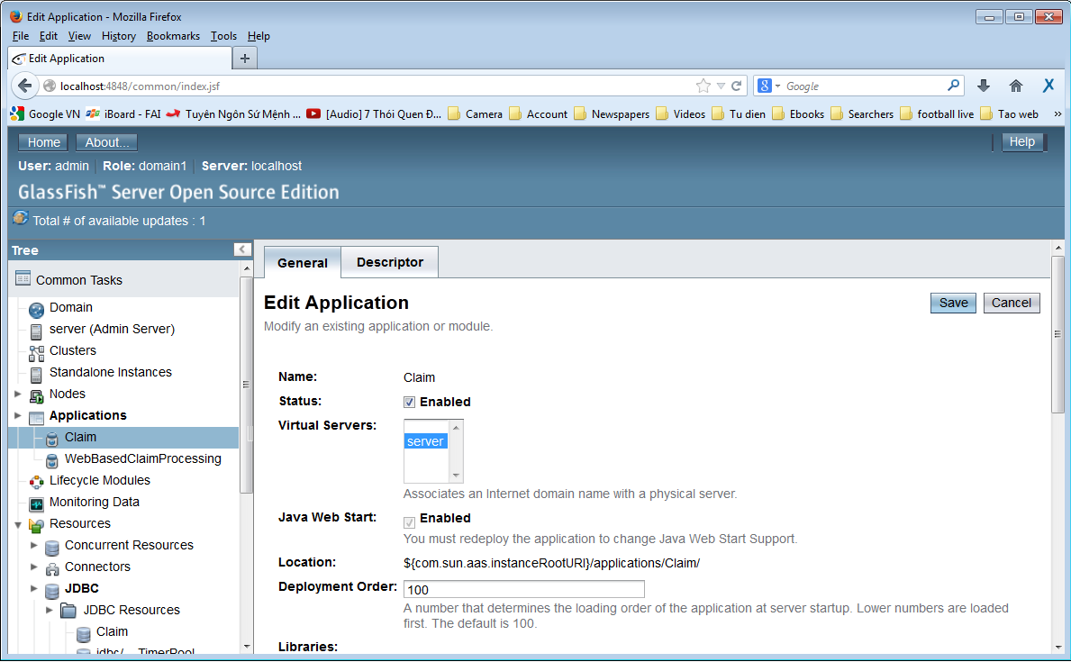

* Scroll down until see the Launch link :

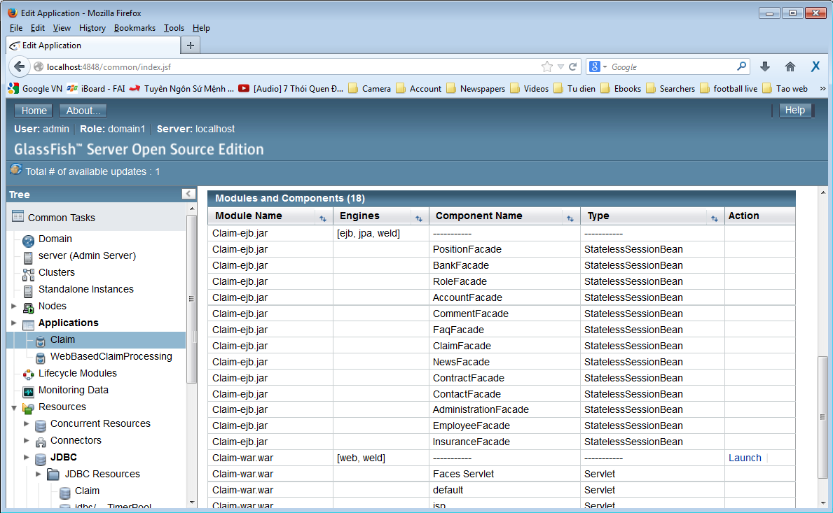

* Click the link to continue :

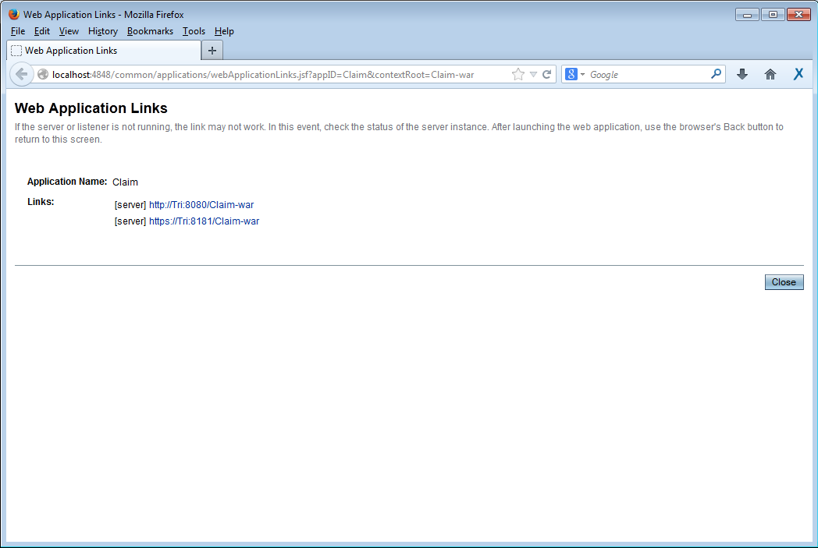

* This is the link to anyone want to use this service .